Program: Sickle Cell Disease (SCD) Radio Awareness Raising and Sensitisation Campaign
Sponsor: Sickle Cell Support Society of Nigeria (SCSSN) - Pfizer Specialties Ltd
Locations: Selected Cities in the Six Geo-Political Zones of Nigeria
Duration: One Month of Radio spots, Three months of live programs
Dates: May 2026 - September 2026

The Radio Awareness Raising and Sensitisation Campaign project to encourage New Born Screening & Clinical Care Follow-up for Sickle Cell Disease (SCD) was initiated with key objectives to improve awareness, encourage more families to participate in newborn screening and ensure babies who test positive are brought back for follow-up clinical care. Radio stations were carefully selected for all demography and multiple touch points to cover specific areas in the six geopolitical zones across Nigeria.

1.0 Program Design

Produce radio jingles on SCD newborn screening and Follow-up care, focus radio campaign in selected radio stations across the six geopolitical zones of Nigeria. Radio presenters and guest experts trained to ensure message consistency. Point of care test kits distributed through coordinators of the six zones to encourage engagement. The combination of radio jingles with interactive phone-in programmes will measure program impact.

2.0 Campaign Metrics

Zone | No. of Radio Stations  (Target: 12) | Radio Spots  (Target: 360) | Remarks |  | Live Programs  (Target: 18) | Remarks
South South | 3 | 100 |  |  | 9
North East | 2 | 93 | includes Hausa, Kanuri, Pidgin English |  | 6 | including in Hausa and Kanuri
North West | 4 | 63 |  |  | 7 | including in Hausa
South West | 3 | 60 | includes Yoruba |  | 9 | including in Yoruba
South East | 5 | 60 | includes Igbo |  | 10
North Central | 4 | 82 |  |  | 11
TOTAL | 21 | 458 |  |  | 52

3.0 Interventions

- Product: FAQs sheet on SCD care and on Newborn screening for training radio presenters.
- Training: Organise 3 training sessions for radio presenters and program guests
  - May 21, 2026: 39 trainees from 15 radio stations; faculty of 7 resource persons including 3 SCSSN zonal coordinators (SW,SS,NW)
  - June 1, 2026: 42 Trainees from 19 radio stations; faculty of 2 resource persons
  - Aug 13, 2026: 23 Trainees from 14 stations; faculty of 3 SCSSN coordinators (SW SS, NW); CESRTA team; 3 Warriors
- Multi-lingual jingles and live programs: Ensure cultural relevance through translations into dominant regional languages of pidgin-English, Hausa, Igbo, Kanuri, and Yoruba for more extensive local reach
- Live Programs: Used more prime time general interest programs than special health programs for greater reach.

4.0. Impact and Lessons

Qualitative feedback in the testimonials indicate that the training and live programs achieved the objectives of building media capacity, improving SCD awareness programming content, increasing listener knowledge through audience engagement and promoting positive attitude towards SCD warriors.

4.1 Audience Lessons:
- Greater coverage of SCD prevention and management strategies
- More radio programs in local languages with more narratives from SCD warriors to reach under-served communities
- More discussions on family support and caregiving

4.2 Broadcasters learned:
- Need for health information to be accurate and evidence-based
- That effective health communication requires simple and relatable language
- Audience engagement improves programme quality and impact

4.3 Challenges:
- Achieving satisfactory message saturation and measurable behavioral change with limited program duration and funding
- Securing guests and managing unexpected live program changes
- Simplifying medical information without losing accuracy, especially in the local languages

5.0 Conclusion and recommendation

The Radio Awareness Raising and Sensitisation Campaign to Encourage New Born Screening & Clinical Care Follow-up for Sickle Cell Disease warriors was successfully carried out in more radio stations and with more live programs than originally planned, which partially mitigated the challenge of execution, the guest pool was expanded, pre-recorded programs were utilised in a few instances while the factsheet enabled more standardised messaging.
Collective feedback demonstrates that radio remains a powerful tool for SCD awareness especially in under-served communities. The training equipped journalists with the knowledge and skills needed to produce impactful content, while listener responses confirmed a strong need for sustained public education on newborn screening, genotype testing, stigma reduction, and support for Sickle Cell Disease warriors.
Recommendations include:
- Continued investment in media training and public awareness programming
- Utilise feedback to improve program design features for a full national campaign
- Develop a system for sustaining the campaign after this initial (pilot) funding

6.0 Campaign Summary

Region | Cities | Radio Stations | Jingles  Dates  2026 | Phone-in Dates 2026 | Remarks/ Results | Link
South South | Uyo | Inspiration FM, Uyo | 23 May -21 Jun | 28 May  15 Jun  10 Jul  4 Sep  11 Sep | 90 spots | https://drive.google.com/file/d/1RttPyYr-YXkAx-9VgViMLcnHEgCI0lva/view?usp=drive_link  https://drive.google.com/file/d/14xon2plfsAhKL0ISL_g1x8bc4gHk1Drp/view?usp=drive_link  https://drive.google.com/file/d/1SS6TPrpnZCpRAs6HQL2yTGrbssXCXrFg/view?usp=drive_link  https://drive.google.com/file/d/1gKRf0Rj9d2efjjrwNeKdtdocbOm5crqf/view?usp=drive_link  https://drive.google.com/file/d/1ZnbllKfTDvAAETw-20mn58Kw3EJiBAl0/view?usp=drive_link
South South | Uyo | Comfort FM, Uyo |  | 19 Jun
South South | Calabar | HIT FM |  | 18 Jun  15 Jul  29 Jul | 10 Spots | https://drive.google.com/file/d/1itB41bEfXRXo2JG1lDDTLXJkfErWI_9w/view?usp=drive_link  https://drive.google.com/file/d/1bi4ICu2-AU9qZL2rCJmIaXWeik-EciDO/view?usp=drive_link
North East | Maiduguri | Peace FM, | 31 May -30 Jun | 9 Jun  13 Jun  15 Jun  17 Jun  15 Jul | 93 Spots English, Kanuri & Hausa live programs | https://drive.google.com/file/d/1J9xaMkQ8I8STnoBU1z3dbkaiFUdopLjb/view?usp=drive_link  https://drive.google.com/file/d/1MEIaJcmWJNa6QKoXD8FZHLJjmHcl_uZ2/view?usp=drive_link  https://drive.google.com/file/d/193i30Pwb03PYhp5GUvPeEDsaieg8Q0UJ/view?usp=drive_link  https://drive.google.com/file/d/1uYuPtNzdhxEmJXCK9zKe1XFotKFE9Izr/view?usp=drive_link  https://drive.google.com/file/d/1rlrYXSqbegb1Qu8Uk_gKGHR3HtacRHAU/view?usp=drive_link
North East | Yola | Usaku FM |  | 13 Jul
North West | Kebbi | Nagari FM, Kebbi | 9Jun-18Jun | 18 Jun | 30 Spots
North West | Kaduna | Nagarta Radio | 7Jun-6Jul | 17Jun (Hausa)  22 Jul |  | https://drive.google.com/file/d/1SggXMxaLZDhahFBebWcGeeNREmm6R4Ze/view?usp=drive_link  https://drive.google.com/file/d/1YkyJLrJ97uRYIDE6GnVFMxaMGukXiBxS/view?usp=drive_link
North West | Zaria | ABU Radio | 7Jun-29 Jul | 11 Jun |  | https://drive.google.com/file/d/1wGPPmRUEyvj3vGBiQ1KoiE5GU2By8XU7/view?usp=drive_link  https://drive.google.com/file/d/1LQhmwIsSAiTm9X16hmkcgJlol5lccn-p/view?usp=drive_link
North West | Zaria | Queen FM | 7Jun–10 Jul | 10Jun (Hausa)  19 Jun  21 Jul | 33 Spots | https://drive.google.com/file/d/1X02cnlv3otVmtbihJpAq3MrzKxSL7s8X/view?usp=drive_link  https://drive.google.com/file/d/1puZKgGFHH6uKj3yD2LPZXi6TeeD6PyPu/view?usp=drive_link
South West | Ife | Crown FM, Ife | 18Jun-18 Jul | 19 Jun  3 Sep  10 Sep | 30 spots  including Yoruba
South West | Ilesha | Diamond Radio, Ilesha | 18Jun-17 Jul | 11 Jul  31 Jul | 30 spots  including Yoruba
 | Lagos | Radio Lagos |  | 23 Jul  30 Jul  06 Aug  13 Aug | Yoruba | https://drive.google.com/file/d/1dRQ2tp-Flue4lDgPPqJGKnXKtmVJs7Te/view?usp=drive_link  https://drive.google.com/file/d/1_pAA8dJdjKbp3LeG-RyzLPyoLx-OfP8C/view?usp=drive_link  https://drive.google.com/file/d/1YncTAfwLezogzfTpygEDslDughof9A3I/view?usp=drive_link  https://drive.google.com/file/d/1JKUSaJayxC4iZ2Wk8tvRFd3TrxCC5Yh3/view?usp=drive_link
South East | Onitsha | Sapienta FM | 19 Jun -15 Jul 2026 (Igbo) | 19 Jun (Igbo) | 60 spots
South East | Ora Ifite | Blaze FM | 13Jun-27Jun | 19 Jun  16 Jul
South East | Ora Ifite | Ijele FM | 13Jun-29 Jun (Igbo) | 17Jul (Igbo) |  | https://drive.google.com/file/d/1CnnkcQ6wnCytaNUMIj19Hlq8zm_TBnJ0/view?usp=drive_link
South East | Enugu | Dream FM |  | 18 Jun  23 Jul  30 Jul  1 Sep  8 Sep |  | https://drive.google.com/file/d/1lQLn7HDbStrbzoe77xZVSePrckqJ2XJQ/view?usp=drive_link
South East | Nnewi | Authority FM |  | 21 Jun
North Central | Abuja | Kapital FM (FRCN) | 2Jul-31Jul  extended to 11 Aug 2026 | 20 Jul  22 Jul  28 Jul  31Aug (rec)  7Aug (rec)  14Aug(rec) | 60 spots  22 added | https://drive.google.com/file/d/1pChh8AibRu3NPU-hbQjUR2ZYXqyBOKES/view?usp=drive_link  https://drive.google.com/file/d/1KeE1oizJdzs7ZqqdJ4wFHnh_aV7sb68z/view?usp=drive_link
North Central | Abuja | Kids FM |  | 21 Jul
North Central | Abuja | Municipal FM |  | 15 Jul
North Central | Abuja | Global TV |  | 23 Aug |  | https://youtu.be/jtg_bCvxx-Y?si=nYjvJt4ldu8sGf_S
North Central | Jos | PRTV, Jos |  | 3 Jun  21 Jul |  | https://www.youtube.com/live/BU_O4DJ1Q-o?si=aOkl5DP6_GLIe50k

7.0 Resources

- SCD & Newborn Screening FAQ | 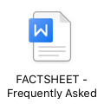
- Testimonials | 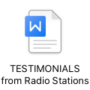

8.0 PICTURE GALLERY

FRCN Kapital FM, Abuja FCT
Inspiration FM, Uyo, Akwa Ibom State
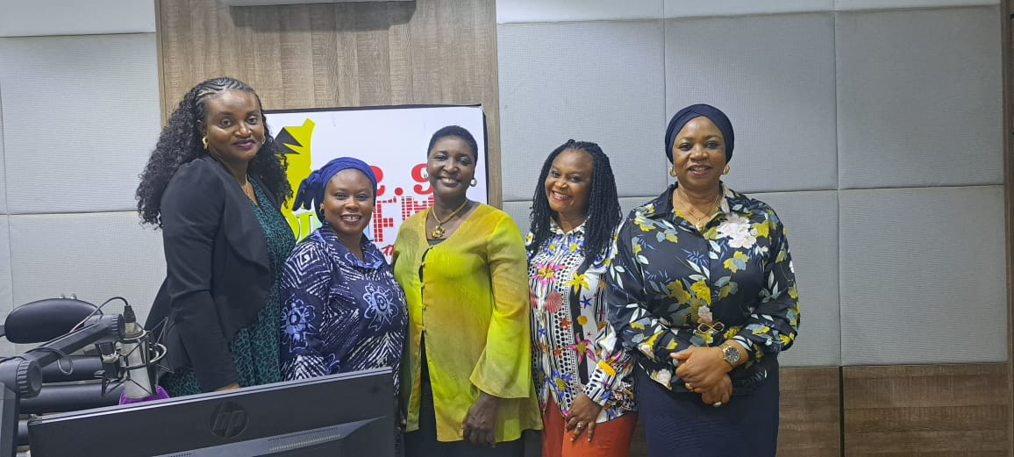
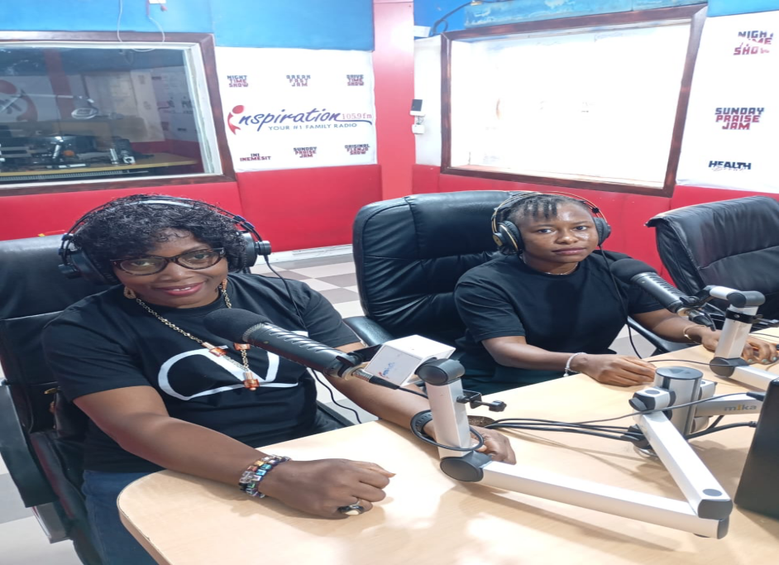
Inspiration FM - Uyo, AKwa Ibom State
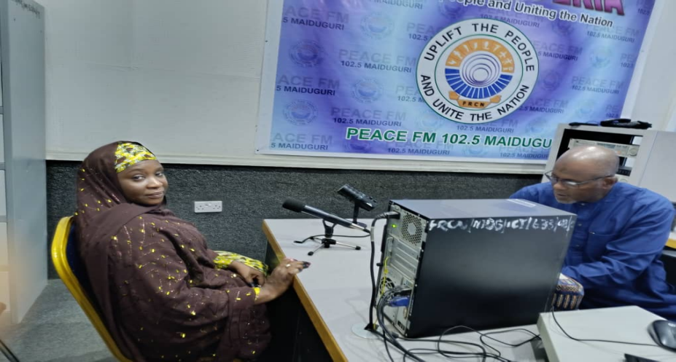
Peace FM, Maiduguri, Borno State - KANURI language Live Porgram
